18.8: a) 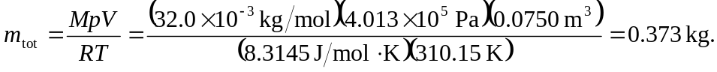
b) Using the final pressure of 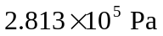and temperature of 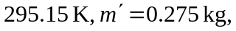
so the mass lost is 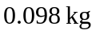where extra figures were kept in the intermediate calculation of 

